238 USING YOUR WHOLE BRAIN 221001

ARE YOU USING YOUR EMOTIONAL INTELLIGENCE? (EI)

Your Head Hosts Two Brains!

Your brain processes information in two very different ways! One side is logical, rational, and deductive. This is the cognitive side of your brain and is measured by your IQ.

The other side processes information emotionally—its source of information is based on memory and pictures. You visit a beautiful ocean with white fluffy clouds and the sound of waves breaking on the shore, and your body relaxes. Whenever you “see” that memory, your body re-experiences it and relaxes as if you were still at the ocean. On the other hand, if you view a traumatic incident in which someone dies, you may re-experience the anxiety and fear you felt at that time. Whenever you bring those memories up, you will experience the same feelings as if they were happening right now. Both examples are of Emotional Intelligence (EI).

Emotional Intelligence — the skill of knowing what you feel and then choosing to feel something different by choosing to “see” a different picture. This ability is critical to your work and life success.

You were born with the ability to recognize when you are experiencing an emotion. When you were born, you readily would tell others when you were angry, happy, and sad, and you could choose to express these feelings at will. As you grew older, you likely learned how to disregard your emotions, hide them as often as possible, and rationalize why you feel the way you do to deal with the situation in socially acceptable ways.

No matter what people tell you about the evils of emotions, such as, “You should not feel that way,” “Nice girls do not get angry,” “Pretty is as pretty does,” and “Anger is a sin,” the truth is your emotions are not good or bad, right, or wrong, they just are. What you choose to do (your behaviors) with your feelings can get you into trouble. Being angry has never put anyone in prison.

If you don’t recognize your feelings, you cannot fully understand what motivates your actions. This lack of awareness limits your ability to choose how you want to feel and act, negatively impacting your relationships, job performance, and overall happiness. Your upbringing likely stunted the development of your emotional intelligence.

Emotional Intelligence—EI also increases your understanding of others: what motivates them, how they work, how to work cooperatively with them, and how to inspire them to reach their potential. The University of Maryland, Robert H. Smith School of Business created an excellent infographic that explains the value of using Emotional Intelligence at work. See the list below for how a low EI will affect you:

Signs you may be lacking or forgetting to access your Emotional Intelligence
__ You blame other people for your problems or errors.
__ You don’t take feedback well, get defensive or shut down when comments are offered that hurt your feelings.
__ You get impatient and frustrated when you think others don’t understand or appreciate what you are saying or doing.
__ You don’t forgive people easily. You hold grudges and resentment over things, some of which happened many years ago.
__ You are judge people for who they are, what they wear, what they say, or what they do based on what you think is correct and best (you shoulds).
__ You are very selective and picky with whom you will spend time and share your thoughts.
__ You give your opinions early in a conversation and hold on to them no matter what anyone says (listening to respond, not learn).
__ You like to declare that you don’t care if people like you or not.
__ You think emotions are overrated, and it doesn’t matter what you or other people feel.
__ You quickly challenge new ideas that might impact your work (fixed vs. growth mindset).

Signs you are using your Emotional Intelligence:
√ You are resilience and flexible.
√ You are listening and accepting, even if you don’t agree.
√ You are willing and able to forgive, both yourself and others, and you can do so quickly and completely.
√ You take 100% emotional responsibility, knowing that every one of your thoughts, feelings, decisions, and actions are Yours. You created them, so you can manage them.
√ You seek others’ points of view.
√ You understand, accept, and can explain your emotional reactions, and you can change your reactions into emotionally- and cognitively-informed responses (IQ + EQ = !!!),
√ You stay calm under pressure and strong emotional situations.
√ You use emotions appropriately to connect with, inspire, and make others feel comfortable.
√ You admit and learn from mistakes (continuous improvement).
√ Taking feedback with grace and ease,
√ Your body language matches your words (emotional congruence).

Short of attending a training session, here is something you can do now to increase your emotional intelligence. First, look at the chart below. Notice that your behavior is based on your feelings, which are based on your cognitive thoughts plus your emotional pictures. Something is said or happens (EVENT) You put a MEANING(s) to the event FEELING(s) result, from which consciously or unconsciously you choose your BEHAVIORS.
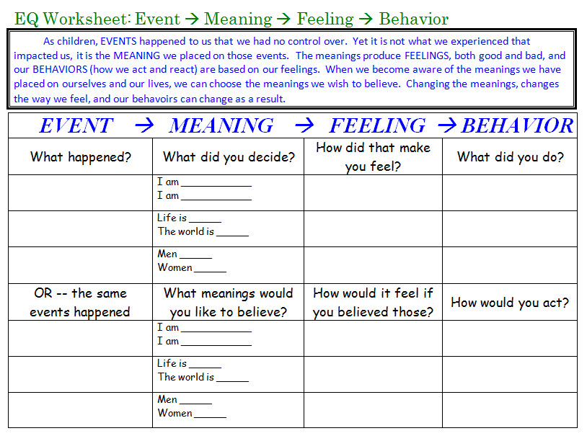
Worksheet created by Matt Perelstein for NewDirectionsWorkshops.com

What happened to you?
What meanings or judgments about yourself, others, and your world did you put on what happened to you?
What feelings resulted from your chosen meanings?
What did you do because of those meanings and feelings?

The meanings that you choose can be positive or negative, general or specific, helpful or not helpful. For example, “I really messed up that time; something must be wrong with me; I will never succeed.” OR, “Yeah, I messed up that one (acceptance). That was hard to learn; I do not need to do that again. Next time, I am going to do it this way instead.”

Very few people know that they choose to think! They see themselves as the victims of thoughts, not the producer of thoughts. You can think anything you want to think. Mary thinks that she is not very pretty. Only what Mary thinks about herself makes her feel unattractive (Meaning Feelings). Joe has PTSD and believes that the world is unsafe and that he is unsafe in this world. The world is not dangerous; only what Joe believes about the world makes him feel unsafe.

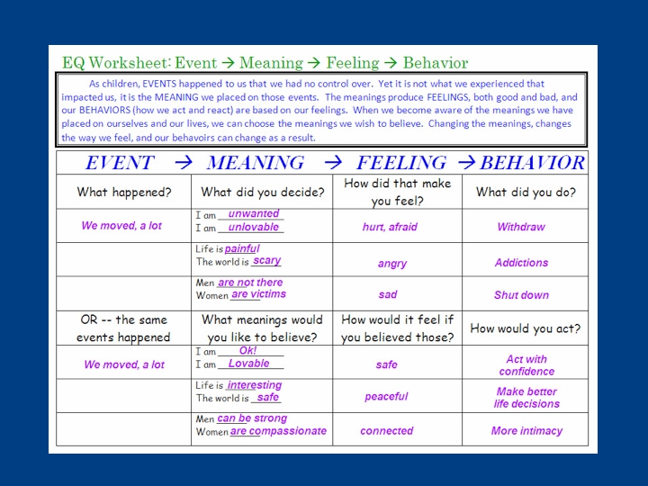
Matt’s example

Can you see from the example how Matt’s meanings affected his feelings and behaviors?

You can also have more than one belief or meaning from any event, and each meaning will produce different feelings or emotions. For example, you could have two different meanings that might make you feel joy and jealousy at the same time.

To use this information, you can use this chart to help you go in either direction. Start at the one of the three areas you are most aware of, such as “I am aware that I am feeling angry.” Then go backward to the meanings and figure out what you are thinking that is creating the feelings of anger “She just used and took advantage of me.” Now that you know what you were thinking, what else could you have thought? “She must be feeling very powerless and need to put me down.” (#SpinIt2WinIt)

Here are some more exploratory questions to ask yourself:
- What triggers you to react with high emotions?
- What thoughts and feelings are you experiencing right now?
- What would you like to get from the situation (for example: respect, appreciation, or control)?
- How could you respond to someone who was feeling powerless so that you get a different/better response?

Good luck in your self-exploration. If you can discover where your original negative meanings and feelings started, you can change your two brains into one, making your thoughts and feelings work for you, rather than against you.

You can contact Dr. Downing at:
Email: DocDowning103@gmail.com
Website: DocDPhD.com

